Easter Sunrise Service

April 12, 2020

Prelude – “Christ the Lord is Risen Today” (Mark Pardue, trumpet)

As We Gather – Allison and Alleigh Milam

This is the day
when tears are wiped away; shattered hearts are mended; fears are replaced with joy.
This is the day the Lord
rolls away the stone of fear; throws off death’s clothes; goes ahead of us into God’s future.
This is the day the Lord has made:
death has no fear for us; sin has lost its power over us; God opens the tombs of our hearts to fill us with life.
This is the day – Easter Day!
Christ is Risen! Hallelujah!

Musical Reflection – “Christ is Alive”
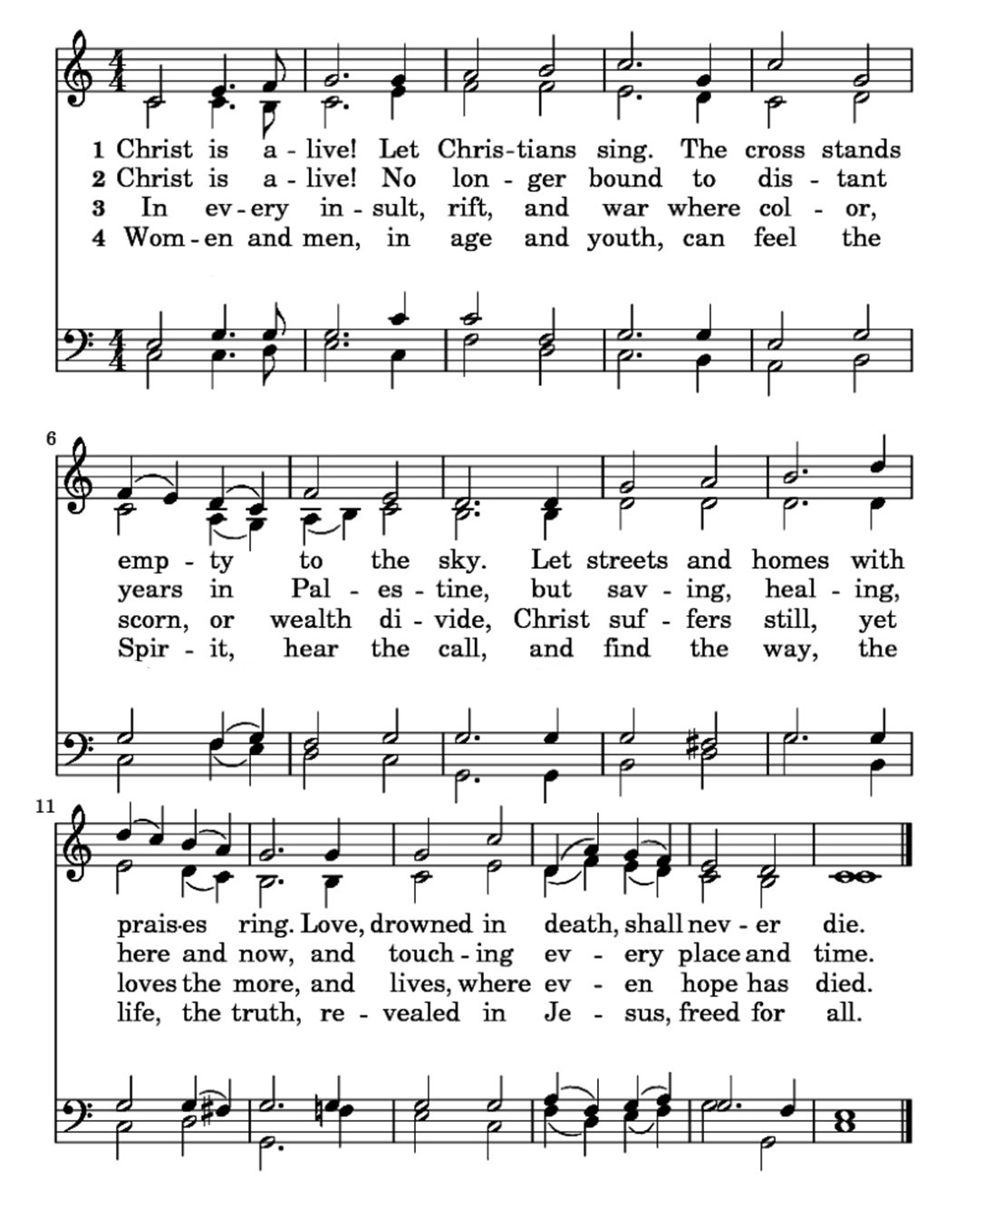

Psalm Lesson (Psalm 107) -

“Give thanks to the Lord because he is good, because his faithful love lasts forever!” Some of the redeemed had gone out on the ocean in ships, making their living on the high seas. They saw what the Lord had made; they saw his wondrous works in the depths of the sea.
God spoke and stirred up a storm that brought the waves up high. The waves went as high as the sky; they crashed down to the depths. The sailors’ courage melted at this terrible situation.
They staggered and stumbled around like they were drunk. None of their skill was of any help.
So they cried out to the Lord in their distress, and God brought them out safe from their desperate circumstances.
God quieted the storm to a whisper; the sea’s waves were hushed. So they rejoiced because the waves had calmed down; then God led them to the harbor they were hoping for. Let them thank the Lord for his faithful love and his wondrous works for all people.

Help Me to Believe in New Beginnings - Leslie Koger

God of history and of my heart, so much has happened to me during these whirlwind days:
I’ve known death and birth; I’ve been brave and scared; I’ve hurt, I’ve helped; I’ve been honest, I’ve lied; I’ve destroyed, I’ve created; I’ve been with people, I’ve been lonely; I’ve been loyal, I’ve betrayed; I’ve decided, I’ve waffled; I’ve laughed and I’ve cried. You know my frail heart and my frayed history – and now another day begins.
God, help me to believe in beginnings and in my beginning again, no matter how often I’ve failed before. Help me to make beginnings: to begin going out of my weary mind into fresh dreams, daring to make my own bold tracks in the land of now; to begin forgiving that I may experience mercy; to begin questioning the unquestionable that I may know truth, to begin disciplining that I may create beauty; to begin sacrificing that I may make peace; to begin loving that I may realize joy.
Help me to be a beginning to others, to be a singer to the songless, a storyteller to the aimless, a befriender of the friendless; to become a beginning of hope for the despairing,
of assurance for the doubting, of reconciliation for the divided; to become a beginning of freedom for the oppressed, of comfort for the sorrowing, of friendship for the forgotten;
to become a beginning of beauty for the forlorn, of sweetness for the soured, of gentleness for the angry, of wholeness for the broken, of peace for the frightened and violent of the earth.
Help me to believe in beginnings, to make a beginning, to be a beginning, so that I may not just grow old, but grow new each day of this wild, amazing life you call me to live
with the love of Jesus Christ. All of this I can be and do – not on my own – but through the power of your resurrected Son. Amen. (by Ted Loder)

Gospel Lesson (Mark 4) - Dan Koger

Later that day, when evening came, Jesus said to them, “Let’s cross over to the other side of the lake.” They left the crowd and took him in the boat just as he was. Other boats followed along. Gale-force winds arose, and waves crashed against the boat so that the boat was swamped. But Jesus was in the rear of the boat, sleeping on a pillow. They woke him up and said, “Teacher, don’t you care that we’re drowning?” He got up and gave orders to the wind, and he said to the lake, “Peace! Be still!” The wind settled down and there was a great calm.

Meditation - Dan Koger

Celebrating the Resurrection – Kara and Alyssa Miller

Christ is risen! Go forth in joy.
From darkness and despair, we go to share Christ’s hope and joy.
Christ is risen! Go forth in faith.
From doubt and betrayal, we go to walk in faith and trust.
Christ is risen! Go forth to live.
From suffering and death, we go to heal a broken world.
Christ is risen!
Christ is risen indeed! Alleluia.

Musical Reflection – “Easter Song” (by Glad)

