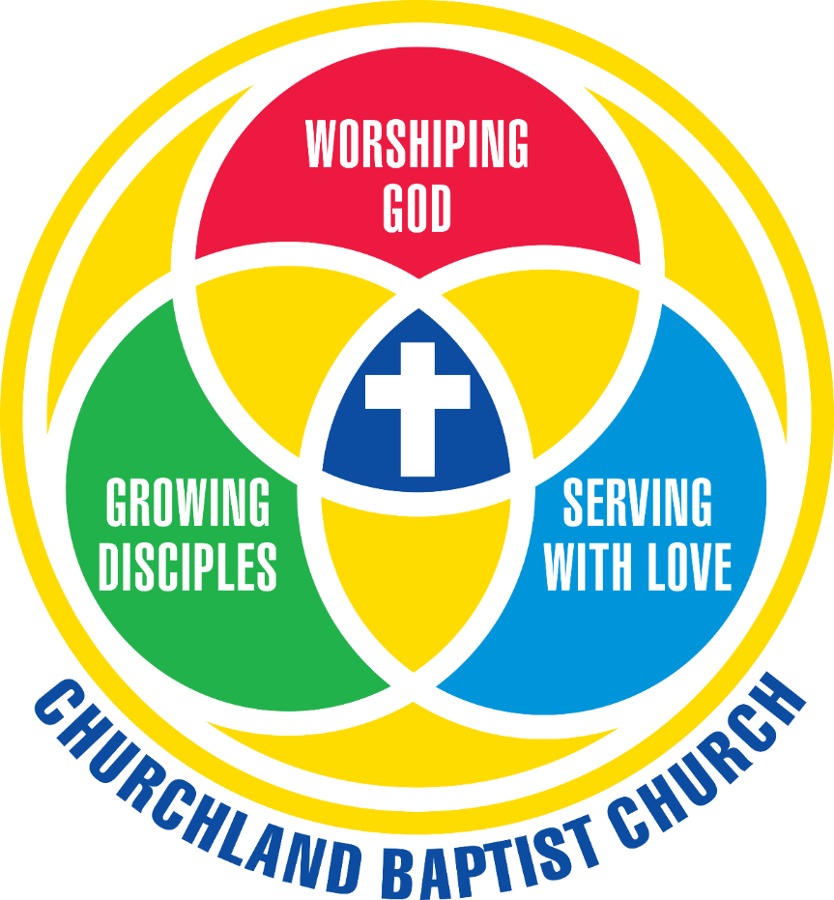

Bylaws

PREFACE

We adopt the following bylaws as guidelines for the members of Churchland Baptist Church to preserve harmony and order in the church body and assist one another in our Christian work and service:

ARTICLE I
NAME AND OBJECTIVES

Section 01 NAME: This church will be known as Churchland Baptist Church.

Section 02 MISSION: The mission of Churchland Baptist Church is worshiping God, growing disciples, and serving with love.

Section 03 OBJECTIVES: This church, believing in Jesus Christ, the Son of God, to be the Savior of the world; believing in the Bible as the word of God and the sole authority for faith and practice; and acknowledging its adherence to the divinely revealed truth of God, declares its purposes:
- To maintain regular services for both devotional and public worship.
- To proclaim earnestly, and to urge personal acceptance of, the gospel of Jesus Christ as our Lord and Savior.
- To participate heartily through prayer, giving, and service in establishing the kingdom of Christ locally and throughout the world.
- To promote systematic Bible study and training for a Christ-like walk of life and service.

ARTICLE II

MEMBERSHIP

Section 01 WELCOMING OF MEMBERS: Churchland Baptist Church will welcome members based on their stated desire for membership and either baptism, letter of transfer, or a statement of faith. To welcome a new church member, the Pastor will present the person’s basis for membership to the congregation in the sanctuary at end of worship. The Pastor will request that the congregation welcome the person as a new member by acclamation. The church clerk will document the person’s admittance in a quarterly clerk’s report as of the day the new member is welcomed by congregation.
- Baptism: Any person desiring to be a church member and acknowledging a prior baptism will be welcomed into membership.
- Statement of Faith: Anyone desiring membership, who has not been baptized, will be welcomed as members upon their statement of faith that Jesus Christ is Lord and Savior. The church does not require baptism in recognition of its mission to grow disciples, both internally and externally to the church’s membership.
- Letter of Transfer: Members from other Christian churches will be welcomed as members upon our receipt of their church letter of transfer, and upon their acknowledgement of a baptism or a statement of faith.

Section 02 ASSOCIATE MEMBERSHIP: Members from other churches of like faith will be welcomed as associate members if they desire to retain their membership in their home church, but wish to affiliate with our church during a temporary relocation to this area. Associate membership includes all the rights and privileges of membership, including service in the ministries of the church.

Section 03 NEW MEMBERS: New members will be informed of the ways they can worship God, grow disciples, and serve with love as part of the church.

Section 04 TRANSFER OF MEMBERS: Any current member, upon request, will be granted a letter of transfer to unite with another church. Letters of transfer will normally be sent to the pastor, secretary, or clerk of the church where the member has requested membership or has joined.

ARTICLE III
OFFICERS AND LEADERSHIP POSITIONS

The congregation will elect church officers, committee chairs, and other leadership positions identified below. They will be responsible to the congregation for carrying out the programs and business of the church, and for keeping their expenditures within the church’s approved annual budget. Officers and people in leadership positions will serve the church as follows:

Section 01 A. DEFINITIONS: These are the definitions of the leadership groups:

Officers: Church officers conduct the official business of the church. They fulfill the legal operational and oversight responsibilities of the church body and represent the congregation in all matters of records, signatures, financial obligations and the conduct of business sessions. Annually elected lay officers are: Vision Team Leader, Moderator, Clerk, Assistant Clerk, Treasurer, Assistant Treasurer, and Trustees.

Vision Team: The Vision Team is the church’s primary leadership group. It is comprised of the Vision Team Leader, Pastor, Deacon Chair, and the Chairs of the Global and Community Engagement, Spiritual Formation, Financial Management, Personnel and Administration, Facilities Management, and Young Christian Formation committees. The Minister of Music and Minister of Children, Youth, and Young Adults are invited to attend as ex-officio participants of the team.

Committee: A committee is a group with a defined area of responsibility that the church determines. The congregation elects committee chairs annually and they serve a term of one year. The committee chair selects at least four additional members to serve for the year.

Lead Team: A lead team is a selected group that has responsibility for a ministry event or project that is short-term in nature with clearly defined start and end times. Any leadership group can create a lead team as the need arises. The sponsoring group will appoint the team leader and will either appoint additional team members, or charge the team leader with the responsibility of selecting additional team members based upon their spiritual gifts and personal abilities, and in consultation with the sponsoring group.

Ministry Team: A ministry team is a selected group with ongoing responsibility for overseeing, planning, and implementing a specific ministry area (e.g., Youth Ministry). The sponsoring leadership team appoints the team leader, who, in turn, selects the team members in consultation with the sponsoring leadership team. Members will be selected with consideration of their spiritual gifts and personal abilities.

Coordinator: A coordinator provides management to a specific ministry or service area that occurs throughout the year. The appropriate committee chair will appoint the coordinator. The coordinator selects individuals, as needed, based upon their spiritual gifts and personal abilities.

B. TERMS OF OFFICE: Unless otherwise stated, all officers, committee chairs, and other elected positions, will be elected to serve a term of one year starting on the first day of January and each may be elected to serve additional terms at the will of the church members. All officers and committee chairs must be church members. Coordinators and ministry teams will serve a one-year term beginning on 1 January.

Section 02 CHURCH LEADERSHIP POSITIONS:

PASTOR: The pastor will conduct the public services of worship, and supervise the general development of the work of the church. The pastor will be a non-voting, ex-officio member of the Deacons, Trustees, Vision Team, and Vision Team committees. The pastor will be chosen as the church directs. The pastor will be responsible for obtaining the pulpit supply when absent. The pastor is responsible for setting annual performance goals and conducting annual and in-year performance evaluations of staff members in accordance with the Personnel Manual.

MINISTER OF CHILDREN, YOUTH, and YOUNG ADULTS: The Minister of Children, Youth, and Young Adults shall plan, coordinate, and conduct children, youth, and young adult ministry. The minister shall be approved by the church considered an officer of the church and an ex-officio member, without vote, of the Vision Team and appropriate committees, as designated by the pastor.

VISION TEAM LEADER: The Vision Team Leader leads and coordinates the overall efforts of the Vision Team. The leader chairs meetings of the team; submits the team’s written reports; and coordinates the work of the lay leadership with the Pastor and Minister of Children, Youth, and Young Adults. The leader facilitates Ministry Roundtable meetings and serves as the moderator for business meetings in the absence of the church moderator.

CLERK and ASSISTANT CLERK: The clerk will keep accurate records of all church business (which will be presented at each business meeting), preserve all church documents in a safe place, and keep a correct register of the membership, including the date and basis of the welcome and departure of members. In January, the clerk will prepare a statistical report of the congregation for the past year and a general record of the work of the church suitable to serve as the annual letter to the Baptist General Association of Virginia. The church will elect an assistant clerk to conduct the clerk’s duties in the clerk’s absence.

TREASURER and ASSISTANT TREASURER: The treasurer will receive and disburse all funds of the church. The Treasurer will account for all money belonging to the church and will, without special vote or authority, within the limits of the church’s annual budget, pay out of the church funds available for the purpose, all salaries, allowances, fixed charges, interest, and utilities. The treasurer will pay all other bills after approval by the proper committee chair. The treasurer will keep a record of all receipts and disbursements with proper vouchers. The treasurer will present interim financial reports at the annual business meeting and the quarterly ministry roundtable meetings. The treasurer will present a year-end report at the first ministry meeting of each new year. The treasurer will be bonded in the amount set by the trustees, the cost of which will be paid by the church. The treasurer will be a member of the Financial Management Committee. The church will elect an assistant treasurer to conduct the duties of treasurer in the treasurer’s absence.

CHURCH MODERATOR: The church moderator will preside over all business meetings of the church congregation. The Vision Team Leader will serve as moderator pro tempore in the absence of the church moderator.

TRUSTEES: The trustees are the titular holders of the real property of the church on behalf of the congregation, and they are responsible for the legal interests of the church. There will be three trustees. A trustee must be a member of the church. All actions of the trustees will be subject to the approval of the church. Their authority and methods of conducting business will be in accord with the provisions of statutes of the Commonwealth of Virginia. Trustees will serve three-year terms, staggered so that one new trustee will be elected each year.

DEACONS: The deacons will be responsible for the spiritual advancement and interest of the church and the care of its members, particularly of their assigned family members; the serving of communion; and other duties in support of the Pastor. The size and need of the congregation will determine the number of deacons. The congregation will elect the deacons who will normally serve a term of three years and may serve additional terms at the will of the church members. With the assistance of the Nominating Lead Team, who will identify candidates, the Pastor will nominate, and the deacons will elect, a deacon chair and vice chair to serve a one-year term.

Section 03 CHURCH LEADERSHIP GROUPS:

VISION TEAM: The Vision Team will provide leadership, direction, and a forum to coordinate, plan, and guide the total work and ministries of the church.

- The mission of the Vision Team is:
- To identify overall church needs, opportunities, and resources.
- To lead and direct the collective efforts of the church, to promote accountability of the Vision Team committees, and to plan, guide, coordinate, and integrate the total work of the church.
- To develop, use, and manage the church’s website, social media, and other communication capabilities to inform the church members and community about the church and its activities.

- The Vision Team will be composed of:
- The Vision Team Leader
- The Chair of each committee
- The Deacon Chair
- The Pastor (without vote)
- The Children’s, Youth, and Young Adult Pastor (without vote)
- The Director, Music Ministry (without vote)

- Spiritual Formation Committee
- The Spiritual Formation Committee is responsible for planning, scheduling, facilitating, and evaluating worship services in the life of the congregation, and, subject to the will of the church, will determine the character of these services, and provide vision and direction in cultivating Christian discipleship. It will guide and nurture church members and their families in integrating their faith, life, and vocation. It will lead the congregation in creating a model for spiritual growth, emphasizing practices and experiences central to developing faith.
- The committee will be composed of a chair and at least four additional members, as required.

- Global and Community Engagement Committee:
- The Global and Community Engagement Committee is responsible for developing and implementing a comprehensive and effective community and global outreach missions program.
- The committee will be composed of a committee chair, chair of the WMU Suzie Person Women on Missions Circle, and at least three additional members, as required.

- Young Christian Formation Committee:
- The Young Christian Formation Committee is responsible for designing a comprehensive ministry of Christian faith formation for infants to young adults, as well as their families, in conjunction with the ministries of the church.
- The committee will be composed of a chair and at least four additional members, as required.

- Facilities Management Committee:
- The Facilities Management Committee will be responsible for management of all church properties including the building, its facilities, audio-visual and Wi-Fi systems, grounds, security, and the cemetery.
- The committee has the authority to approve, by majority vote, the funding of capital improvements and repairs from the Building Fund, up to a limit of $10,000, upon consultation with the Financial Management Committee. The church must approve funding for repairs greater than $10,000. In case of an emergency repair of greater the $10,000, the committee can gain timely approval by majority vote of the Vision Team. The committee must recommend funding for all capital improvements for church approval.
- The committee will be composed of a chair, House and Grounds Coordinator, Cemetery Ministry Team Leader, Audio-Visual Coordinator, and at least one other member, as required.

- Financial Management Committee:
- The Financial Management Committee is responsible for all financial resources of the church including all funds, deposits, and investments The Financial Management Committee will establish policies and procedures for the collecting, counting, safeguarding, disbursing, and investing all church funds. It will be responsible for developing the annual operating budget and presenting it for approval by church members at a business meeting. It will ensure that proper audit procedures are established and that church finances and procedures are audited in accordance with the requirements of the Commonwealth of Virginia. It will ensure the Endowment Fund is operated in accordance with procedures the congregation has approved.
- The Financial Management Committee will be composed of a chair, the Treasurer and at least three other committee members, as required.

- Personnel and Administration Committee:
- The Personnel and Administration Committee will establish guidelines, procedures, and policies for sick leave, holidays, professional leave, vacation, salaries, special service awards, and continuing education for the church staff. In coordination with the Pastor, it is responsible for writing job descriptions and setting annual performance goals. It is also responsible for conducting annual and in-year performance evaluations of the Pastor, and overseeing evaluations of other staff members.
- The committee will be composed of a chair and at least four additional members, as required.

NOMINATING LEAD TEAM:
The Nominating Lead Team is responsible for proposing candidates for church approval to fill vacancies in lay leadership and deacon positions listed in these bylaws. The Pastor will nominate at least three members of this committee for church approval at a called business meeting by the end of July. The team will prepare a nomination slate for presentation and vote at the annual business meeting in October.

LADIES AID SOCIETY SCHOLARSHIP AWARD MINISTRY TEAM:
The Young Christian Formation Committee will establish and oversee this ministry team by appointing a chair and identifying other members, as required. The committee will approve the ministry team’s policies and procedures for awarding scholarships. A copy of the policies and procedures will be made available to any member upon request.

CHURCH COMMUNICATIONS MINISTRY TEAM: The Vision Team will establish and oversee this ministry team by appointing a chair and identifying other members, as required. In coordination with the Vision Team, the Church Communications Ministry Team will develop, maintain, and manage the church’s website, social media, and other communication capabilities to inform the church members and community about the church and its activities.

ARTICLE IV

MEETINGS

Section 01 SUNDAY: The church will meet regularly on each Sunday for Sunday School and the worship service. Communion will be served at least quarterly at a date and time determined by the Pastor and Deacon Chair. Other services may be held at the discretion of the Pastor.

Section 02 WEEKDAY MINISTRIES: Recognizing that Sunday is our primary day to gather as a church, we will endeavor to provide additional opportunities for worship, discipleship, fellowship, and mission engagement on a regular basis throughout the week.

Section 03 BUSINESS MEETINGS: There will be an annual business meeting held in late October, at a date, time, and place determined by the officers of the church, to approve an annual operating budget, to elect church leaders and to start or conclude major church programs and ministries. Additional business meetings and congregation-wide meetings may be called and conducted as the need arises (e.g., vote on capital improvements, repairs over $10,000).

Conducting Business Meetings: The agenda for business meetings will be as follows: (1) opening prayer; (2) approval of the minutes of the last meeting; (3) Clerk’s report; (4) Treasurer’s report; (5) committee reports and other necessary reports; (6) unfinished business; (7) new business; and (8) closing prayer. The moderator will use a modified Robert’s Rules of Order to run meetings. The moderator will modify meeting procedures to allow each member the opportunity to speak for or against a motion before calling for a vote. Further, it is the church’s intent to discuss church issues and differences of opinion with mutual respect and love for each other.

Section 04 MINISTRY ROUNDTABLE MEETINGS: During the 1st, 2nd, and 3rd quarters, the Vision Team will hold congregation-wide, roundtable meetings to get member input on the church’s ministry work, to present updates on the church’s finances, and to address members’ questions. The intent of these meetings is to promote transparency and communication between the church and the Vision Team.

Section 05 WRITTEN REPORTS: At a minimum, the Vision Team leader, six committee chairs, and treasurer will each prepare an annual report for the preceding year to be distributed to the church before the first ministry roundtable meeting of the New Year. These individuals should also provide quarterly reports before other ministry roundtable or business meetings, as required, to keep the congregation informed of activities, key decisions, or the status of projects. The church leaders should maximize their use of online tools, such as the church website and social medial, to provide this information to the congregation and to receive their feedback.

ARTICLE V
General

Section 0l CONDUCT OF BUSINESS: The business of the church will be conducted at business meetings and by a simple majority of those present and voting. At least 25 church members must be present for a vote.

Section 02 THE CHURCH YEAR: For record keeping purposes and ease of operation, both the business and fiscal years of the church will coincide with the calendar year (January 1 through December 31). All organizations and committees within the church will keep correct records of their work. The budgetary and financial records of the officers of the church and those of its organizations will be the property of, and always available, to the church.

Section 03 THE WILL OF THE CHURCH: Committee chairs, officers, trustees and other elected leaders will carry out the will of the church as expressed by its votes. They will act on behalf of the church based on the mandate received by their elected position with consideration of input received from church members.

Section 04 GLOBAL AND COMMUNITY ENGAGEMENT: To emphasize the importance of mission work, the church will support, conduct, and promote global and community engagement through several organizations within the church, and it will collaborate with our local, state and global mission partners.

Section 05 AMENDMENTS: These articles may be amended at any regular or called business meeting of the church by a vote of three-fourths of the members present and voting, provided that the proposed amendments have been sent out two weeks prior to the meeting and announcements have been made at two Sunday morning services of the church. Complete copies of the proposed amendments will be available from the church office upon request.

